**By-Election 2021**

**Final Report**

**University of the Fraser Valley Student Union Society**

**By-Election 2021**

Final Report

Results & Recommendations

Caitlin Garfias Chan

Chief Electoral Officer, 2021

[elections@ufvsus.ca](mailto:elections@ufvsus.ca)

U F V S T U D E N T U N I O N S O C I E T Y | 2021

33844 King Rd Abbotsford BC V2S 7M8 Online: [www.ufvsus.ca](http://www.ufvsus.ca) Phone: (604) 864 4613

**By-Election 2021**

**Final Report**

**Events of Note:**

September 29th, 2021:

1. The UFVSUS Board waived the election policy, which required two (2) campaign events due to the COVID19 restrictions. Therefore, the October 7th & 8th Q&As were cancelled, deciding to do elevator pitches for social media as a replacement.
2. Due to no response from security, the CEO (with permission) sent emails to successful and unsuccessful candidates in lieu of security response.
3. One candidate was ineligible due to a low CGPA.

October 1st, 2021:

1. The all-candidate meeting proceeded as planned; however, candidates could not campaign until students had received approval from security.
2. Security sent approval for candidates to continue; however, the CEO was questioned regarding receiving this information and how the CEO would use it.

October 12th, 2021:

1. Voting started at 9:25 AM by the governance/finance manager
2. The governance/finance manager requested the CEO to forward previous correspondence dating to 2020/2021 between the previous CEO and security due to SUS receiving pushback regarding the CEO requesting information from security about the candidates’ standing with the university.

U F V S T U D E N T U N I O N S O C I E T Y | 2021

33844 King Rd Abbotsford BC V2S 7M8 Online: [www.ufvsus.ca](http://www.ufvsus.ca) Phone: (604) 864 4613

**By-Election 2021**

**Final Report**

**Recommendations:**

1. In future in-person events, the event should be live-streamed, then saved for future viewing. Having videos for student elections available will allow students unable to attend to still learn about their candidates and expose students further into student governance.
2. Because of the success with the elevator pitches, doing these in the future should be highly recommended, if not mandatory. Not only can students on social media see their candidates, but candidates are more exposed to the camera and introduce their potential role through collaboration and preparation.
3. Due to the issues faced with security this election, a reminder should be typed and sent to the facilities and departments involved with elections about the role of the CEO, who occupies the position (student) and any document supporting the CEO to receive confidential and private information.

**Conclusion:**

Even with conflicts among COVID19 restrictions and UFV Security, we managed to start and finish strong. We elected in one VPE, one VPS, and two student reps at large. The elevator pitches garnered 508 views, and student ballots were sent without issue. Four hundred and two (402) students voted in this by-election, making it a 4% voter turnout.

**Election Ruling**

These elections have been free and fair, with all candidates having an equal opportunity. As a result, I recommend to the current Student Union Board that these results be ratified.

U F V S T U D E N T U N I O N S O C I E T Y | 2021

33844 King Rd Abbotsford BC V2S 7M8 Online: [www.ufvsus.ca](http://www.ufvsus.ca) Phone: (604) 864 4613

**By-Election 2021**

**Final Report**

**Voting Results:**

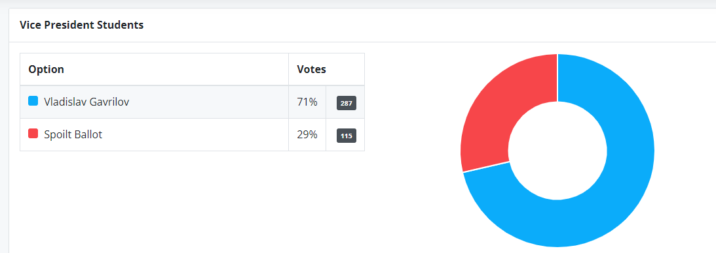

U F V S T U D E N T U N I O N S O C I E T Y | 2021

33844 King Rd Abbotsford BC V2S 7M8 Online: [www.ufvsus.ca](http://www.ufvsus.ca) Phone: (604) 864 4613



**By-Election 2021**

**Final Report**

**Voting Results:**

U F V S T U D E N T U N I O N S O C I E T Y | 2021

33844 King Rd Abbotsford BC V2S 7M8 Online: [www.ufvsus.ca](http://www.ufvsus.ca) Phone: (604) 864 4613